appwrite

to handle back task ( backend )

react is the back bone of key stacks like MERN and PERN

m - mongo db

e - express js

r - react js

n - node js

p - php

e - express js

r - react js

n - node js

2 components in react

functional components ( arrow components )

* Defined using JavaScript functions (including arrow functions).
* **Simpler** and commonly used in modern React.
* Can use **Hooks** (like useState, useEffect, etc.) to manage state and lifecycle.

ex :

function Welcome(props) {

return <h1>Hello, {props.name}</h1>;

}

or

const Welcome = ({ name }) => <h1>Hello, {name}</h1>;

class components

• Older way of writing components (still used but less common in modern code).

• Uses ES6 class syntax and must extend React.Component.

• Has its own lifecycle methods like componentDidMount, render(), etc.

ex :

class Welcome extends React.Component {

render() {

return <h1>Hello, {this.props.name}</h1>;

}

}

card components

In **React**, a **Card Component** is a **UI component** used to present content (like an image, title, description, and actions) in a neat, boxed layout — like a **business card** or **product listing**.

It is **not a built-in** React component — but a **custom component** or **UI library component** (like from Material UI, Bootstrap, or Tailwind).

Ex :

// Card.js

const Card = ({ title, description, image }) => {

return (

<div className="max-w-sm rounded-2xl shadow-lg overflow-hidden bg-white">

<img className="w-full h-48 object-cover" src={image} alt={title} />

<div className="p-4">

<h2 className="text-xl font-semibold">{title}</h2>

<p className="text-gray-700 mt-2">{description}</p>

</div>

</div>

);

};

export default Card;

Usage:  
<Card

title="React Card"

description="This is a simple card component in React."

image="https://via.placeholder.com/300"

/>

Props : ( properties )

In **React**, **props** (short for **properties**) are a way to **pass data** from a **parent component to a child component**.

**What Are Props?**

* Props are **read-only**.
* Passed as **attributes** in JSX.
* Enable **reusable** and **dynamic components**.

**📦 Summary Table**

| **Feature** | **Explanation** |
| --- | --- |
| Props | Data passed to components via attributes |
| Read-only | Cannot be changed inside the component |
| Destructuring | Cleaner syntax to access props |
| Functions as props | Enable communication child ➝ parent |
| props.children | Used to pass nested JSX |

**Props Are Immutable**

You **cannot modify** props inside the child component.

props.name = "New Name"; // ❌ Error

Ex :

const Card = ({ title }) => {  
 return (  
 <div>  
 <h2>  
 {title}  
 </h2>  
 </div>  
 )  
}  
const App = () => {  
 return (  
 <div>  
 <h2>Functional Arrow Component</h2>  
  
 <Card title="Star Wars" />  
 <Card title="Avatar" />  
 <Card title="The Lion King" />  
 </div>  
 )  
}  
  
export default App

to style react app



In react ,inline css has more preference than the external css or other css stylinngs

For most used styling is Tailwind CSS styling

App.jsx and index.css till this

App.jsx

const Card = ({ title }) => {  
 return (  
 <div className="card" style={{  
 border : '1px solid #4b5362',  
 padding: '20px',  
 margin :'10px',  
 backgroundColor : '#31363f',  
 borderRadius : '10px',  
 minHeight : '100px',  
 }}>  
 <h2>  
 {title}  
 </h2>  
 </div>  
 )  
}  
  
const App = () => {  
 return (  
 <div className="card-container">  
 <Card title="Star Wars" rating={5} isCool={true} />  
 <Card title="Avatar" />  
 <Card title="The Lion King" />  
 </div>  
 )  
  
}  
  
  
export default App

index.css

*{  
 box-sizing: border-box;  
 margin: 0;  
 padding: 0;  
}  
  
body{  
 padding: 40px;  
 background-color: #151515;  
 font-family: "Franklin Gothic Medium";  
  
}  
  
h2{  
 color: #f3f3f3;  
 text-align: center;  
  
 font-size: 48px;  
}  
  
.card-container{  
 display: flex;  
 flex-wrap: wrap;  
 justify-content: center;  
  
  
 max-width: 1024 px;  
 margin: 0 auto;  
}  
  
.card{  
  
}

The Most important Concept in react  
  
is STATE

State is like a react component’s brain

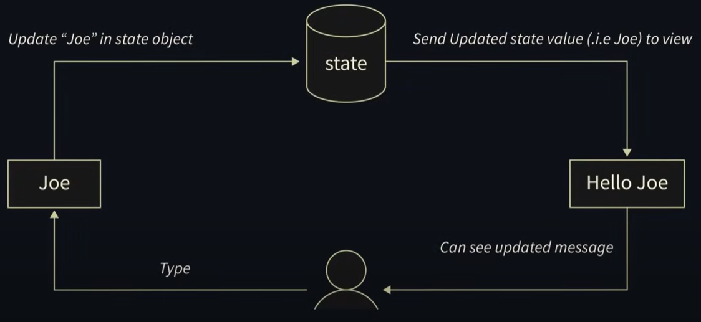

In **React**, state is a built-in object used to **store dynamic data** that determines a component’s behavior and **controls what gets rendered**.

It allows components to **react** to user inputs, API responses, and other events.

**🧠 Difference Between props and state**

| **Feature** | **props** | **state** |
| --- | --- | --- |
| Passed by | Parent component | Managed within component |
| Read-only | ✅ Yes | ❌ No (can be changed) |
| Usage | Communication | Local data & UI updates |
| Mutable | ❌ No | ✅ Yes |

It holds information about the components that can change over time

State Syntax  
  
const [variableName, setVariableName] = useState('')

Hook

In **React**, **Hooks** are **special functions** that let you **use state, lifecycle methods, and other React features** in **functional components** — without needing to use classes.

**🧠 Why Hooks?**

Before hooks, you needed **class components** to use state and lifecycle methods. Hooks make functional components powerful and cleaner.

**🔹 Most Common React Hooks**

| **Hook** | **Purpose** |
| --- | --- |
| useState() | Add state to a functional component |
| useEffect() | Run side effects (API calls, timers) |
| useContext() | Access global data (like themes) |
| useRef() | Access and persist values across renders (like DOM refs) |
| useMemo() | Memoize expensive calculations |
| useCallback() | Memoize functions |
| useReducer() | Alternative to useState for complex logic |

React effect runs twice when the component mounts  
  
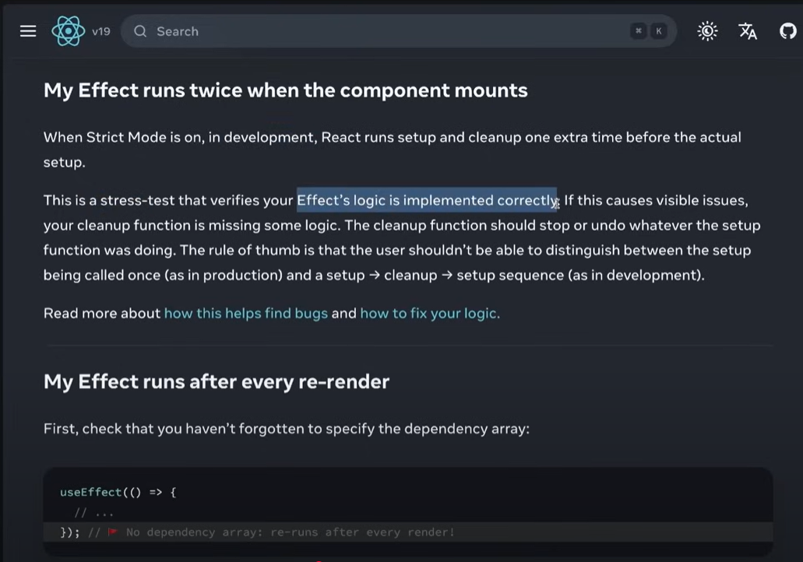

39.32 Till this  
App.jsx , index.css , main.jsx  
  
App.jsx

import {useEffect, useState} from "react";  
  
const Card = ({ title }) => {  
 const [count, setCount] = useState(0);  
 const [hasLiked,setHasLiked] = useState(false);  
  
 useEffect(() => {  
 *console*.log(`${title} has been liked : ${hasLiked}`);  
 })  
  
 return (  
 <div className="card" onClick={() => setCount(count + 1)}>  
 <h2>{title} - {count}</h2>  
  
 <button onClick = {() => setHasLiked(!hasLiked)}>  
 {hasLiked ? "❤️" : "🤍"}  
 </button>  
 </div>  
 )  
}  
  
const App = () => {  
 return (  
 <div className="card-container">  
 <Card title="Star Wars" rating={5} isCool={true} />  
 <Card title="Avatar" />  
 <Card title="The Lion King" />  
 </div>  
 )  
  
}  
  
  
export default App

index.css

*{  
 box-sizing: border-box;  
 margin: 0;  
 padding: 0;  
}  
  
body{  
 padding: 40px;  
 background-color: #151515;  
 font-family: "Franklin Gothic Medium";  
  
}  
  
h2{  
 color: #f3f3f3;  
 text-align: center;  
  
 font-size: 48px;  
}  
  
.card-container{  
 display: flex;  
 flex-wrap: wrap;  
 justify-content: center;  
  
  
 max-width: 1024 px;  
 margin: 0 auto;  
}  
  
.card{  
 border : 1px solid #4b5362;  
 padding: 20px;  
 margin :10px;  
 background-color : #31363f;  
 border-radius : 10px;  
 min-height : 100px;  
}  
  
button{  
 border: none;  
 font-size: 30px;  
 background-color: transparent;  
 width: 100%;  
 text-align: right;  
 cursor: pointer;  
}

main.jsx

import { StrictMode } from 'react'  
import { createRoot } from 'react-dom/client'  
import './index.css'  
import App from './App.jsx'  
  
createRoot(*document*.getElementById('root')).render(  
  
 <App />,  
  
)

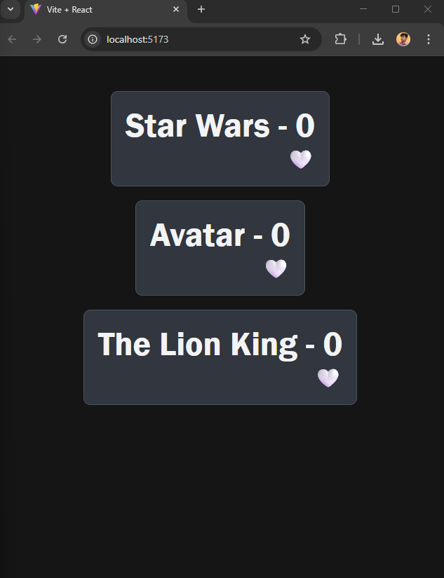

Dependency Array (Deps)

In React, the **"dependency array"** (also called **deps array**) is the **second argument** of the useEffect() hook — and it tells React **when to run the effect**.

The array you pass as the second argument is called the **dependency array** or **deps array**.

**✅ Purpose**

It controls **when** the code inside useEffect() runs, based on **changes to specific variables**.

**🔹 Types of Dependency Arrays**

| **Dependency Array** | **Behavior** |
| --- | --- |
| [] (empty array) | Runs only **once** (like componentDidMount) |
| [var1, var2] | Runs whenever **any listed variable changes** |
| Omitted (no array) | Runs **after every render** (⚠️ not recommended unless needed) |

useEffect(() => {  
 *console*.log(`${title} has been liked : ${hasLiked}`);  
},[hasLiked]);  
  
useEffect(() => {  
 *console*.log('CARD RENDER')  
},[]);

output in console

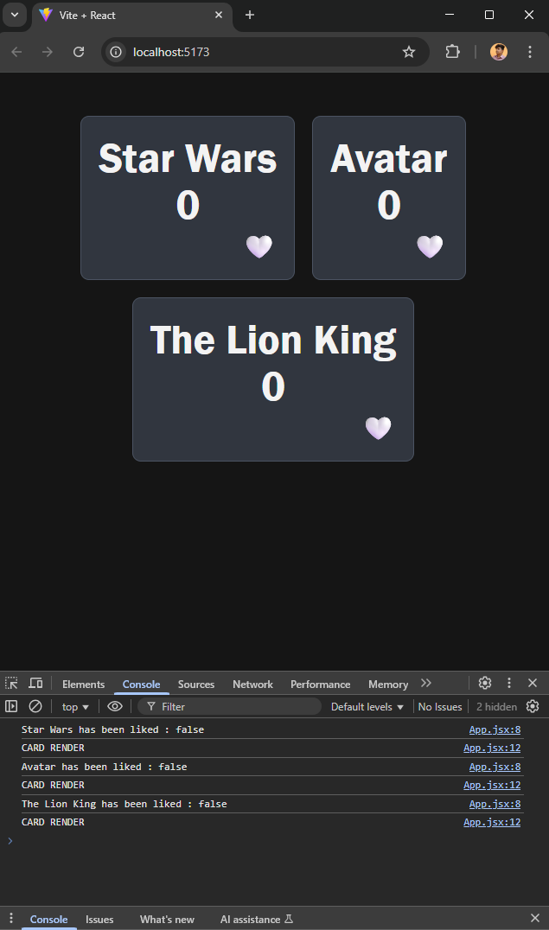

**Conditional Rendering**

**Conditional Rendering** means:

“Show this **only if** a condition is true.”

It works **just like if statements in JavaScript**, but inside JSX.

Ex:

<h2>{title} <br/> {count || null}</h2>

<button onClick = {() => setHasLiked(!hasLiked)}>  
 {hasLiked ? "❤️" : "🤍"}  
</button>

42.45 Till this   
App.jsx , index.css , main.jsx  
  
App.jsx

import {useEffect, useState} from "react";  
  
const Card = ({ title }) => {  
 const [count, setCount] = useState(0);  
 const [hasLiked,setHasLiked] = useState(false);  
  
 useEffect(() => {  
 *console*.log(`${title} has been liked : ${hasLiked}`);  
 },[hasLiked]);  
  
 return (  
 <div className="card" onClick={() => setCount(count + 1)}>  
 <h2>{title} <br/> {count || null}</h2>  
  
 <button onClick = {() => setHasLiked(!hasLiked)}>  
 {hasLiked ? "❤️" : "🤍"}  
 </button>  
 </div>  
 )  
}  
  
const App = () => {  
 return (  
 <div className="card-container">  
 <Card title="Star Wars" rating={5} isCool={true} />  
 <Card title="Avatar" />  
 <Card title="The Lion King" />  
 </div>  
 )  
  
}  
  
  
export default App

index.css

*{  
 box-sizing: border-box;  
 margin: 0;  
 padding: 0;  
}  
  
body{  
 padding: 40px;  
 background-color: #151515;  
 font-family: "Franklin Gothic Medium";  
  
}  
  
h2{  
 color: #f3f3f3;  
 text-align: center;  
  
 font-size: 48px;  
}  
  
.card-container{  
 display: flex;  
 flex-wrap: wrap;  
 justify-content: center;  
  
  
 max-width: 1024 px;  
 margin: 0 auto;  
}  
  
.card{  
 border : 1px solid #4b5362;  
 padding: 20px;  
 margin :10px;  
 background-color : #31363f;  
 border-radius : 10px;  
 min-height : 100px;  
}  
  
button{  
 border: none;  
 font-size: 30px;  
 background-color: transparent;  
 width: 100%;  
 text-align: right;  
 cursor: pointer;  
}

main.jsx

import { StrictMode } from 'react'  
import { createRoot } from 'react-dom/client'  
import './index.css'  
import App from './App.jsx'  
  
createRoot(*document*.getElementById('root')).render(  
  
 <App />,  
  
) 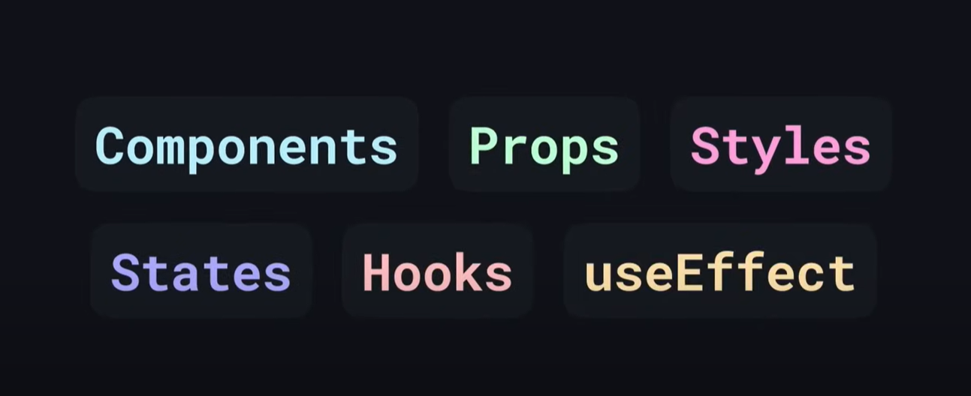

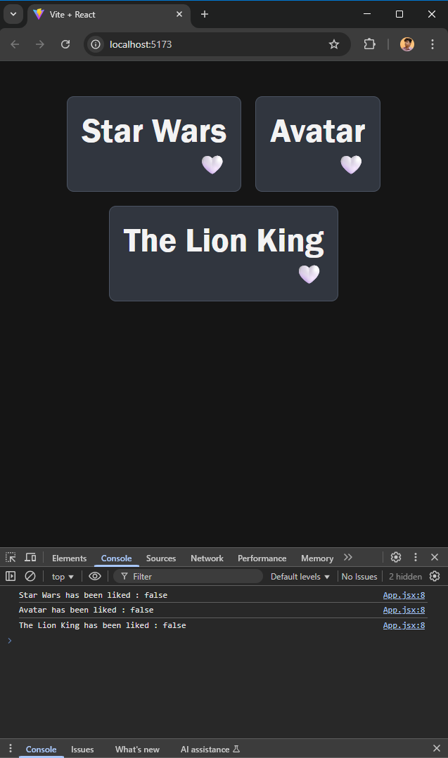

Starting the project

rafce

**R**eact **A**rrow **F**unction **C**omponent with **E**xport

**📌 When to Use rafce**

* When you want to **quickly create a functional component**
* Useful for **stateless components**
* Saves time and typing

**🧠 Other Popular Snippets (from the same extension)**

| **Snippet** | **Purpose** |
| --- | --- |
| rafce | React Arrow Function Component + Export |
| rafc | React Arrow Function Component |
| rce | React Class Component + Export |
| rfc | React Function Component |
| useState | Generates useState hook syntax |
| useEffect | Generates useEffect hook syntax |

Till this









1:30:14 – video time

1:50:44

Finally Completed

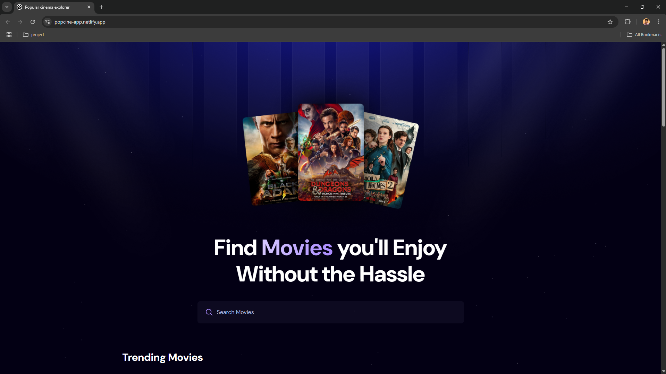

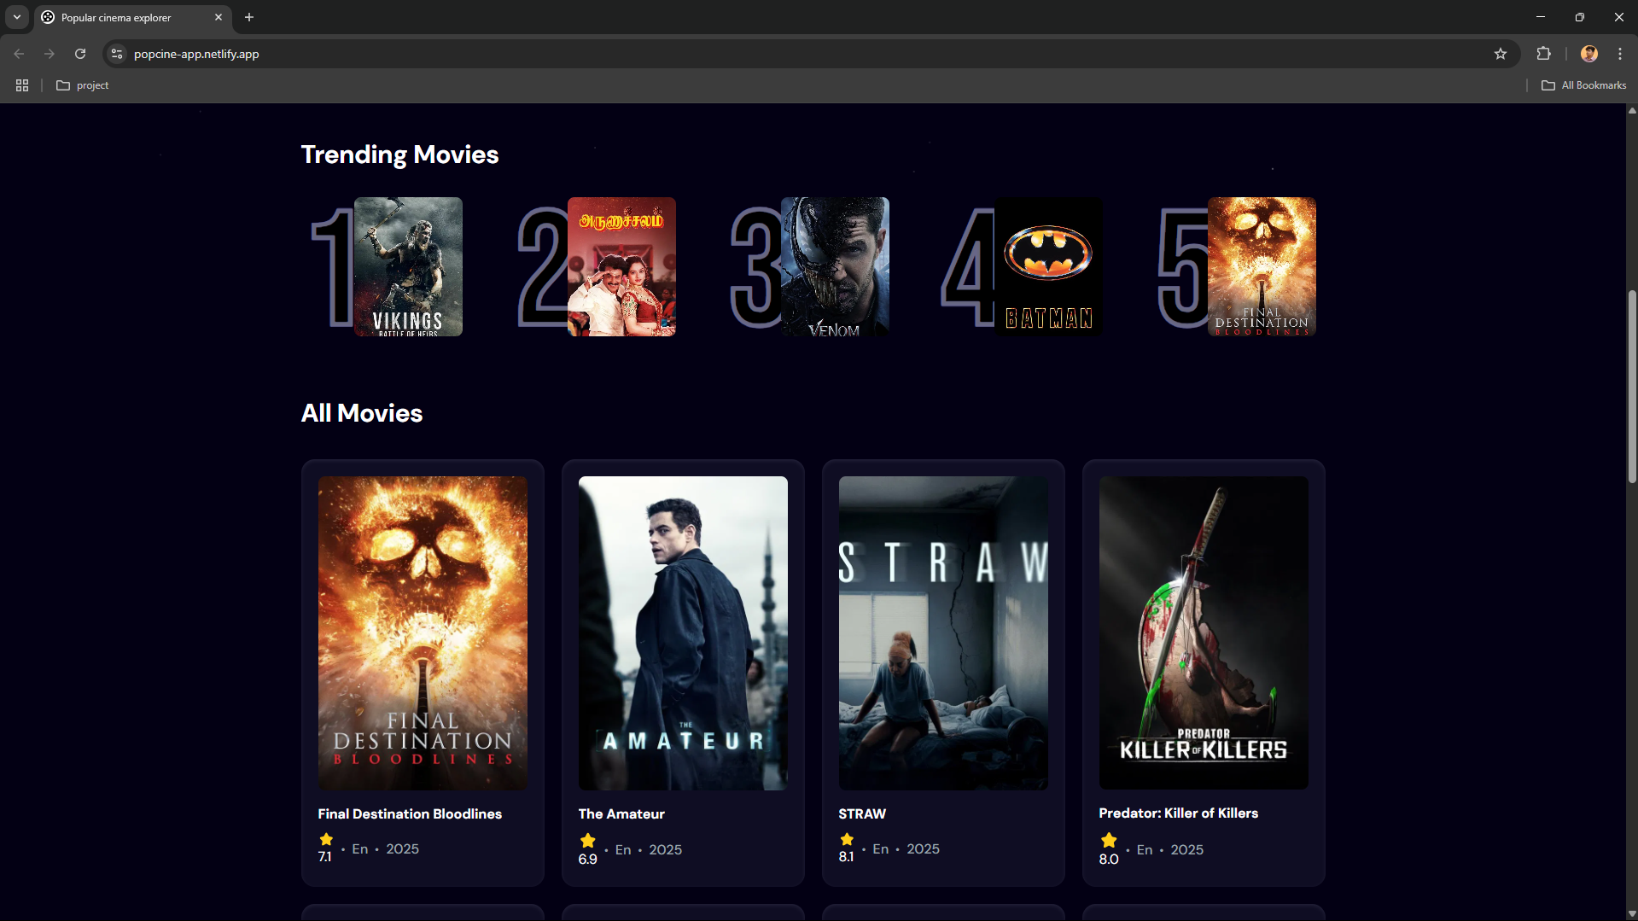

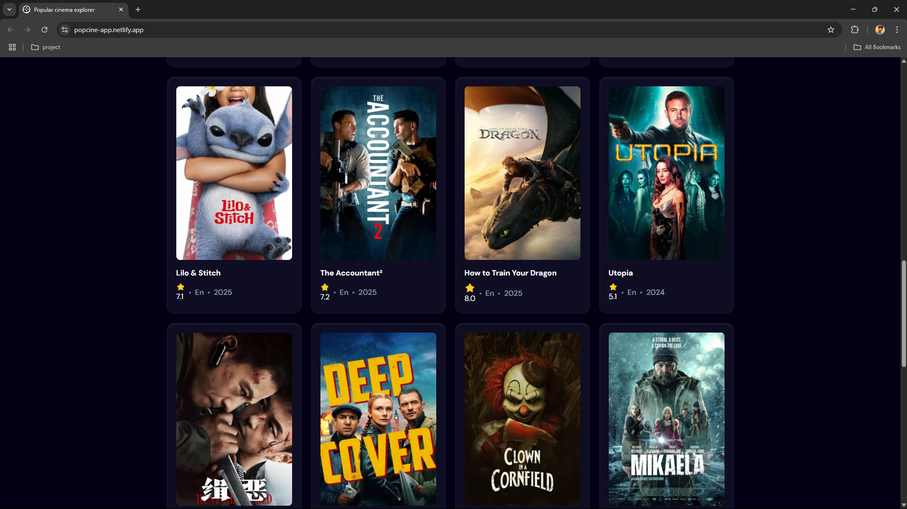

  
  
link: <https://popcine-app.netlify.app/>

